**What Is Business Intelligence?**

* Mobile Business Intelligence refers to the ability to access, analyze, and present business data and insights through mobile devices like smartphones and tablets.
* Business Intelligence (BI) is the process of using data, tools, and techniques to help businesses to make better decisions.
* It involves collecting and analyzing data to understand trends, patterns, and insights that can improve business strategies.
* By using both data analysis and intuition, businesses can identify opportunities, solve problems, and optimize their operations for growth and success.

**Diagram**:

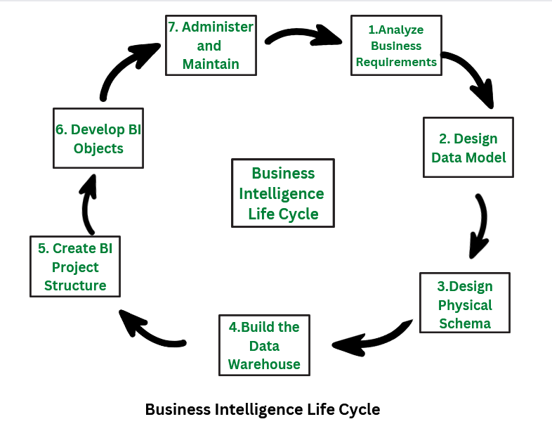

The Business Intelligence (BI) life cycle consists of the following phases:

**Analyze Business Requirements**:

* The first step is to identify business needs to determine the type of analysis required. This helps guide the following actions.
* For example, a retail company might analyze sales data to identify top-selling and least-selling products.

**Design Data Model**:

* After identifying the requirements, the next step is to design a logical data model. This model helps visualize relationships between different data entities.
* For a retail company, the data model would include products, customers, and sales data.

**Design the Physical Schema**:

* The physical schema outlines the structure of the data warehouse, based on the logical model.
* It describes how data is stored and organized.
* In a retail system, this could include sales-related facts and product-customer relationships.

**Build the Data Warehouse**:

* With the schemas in place, the data warehouse is created, and data from source systems is loaded for further analysis.
* For example, a retail company would build a database to store customer, product, and sales information.

**Create the Project Structure (Metadata)**:

* This phase involves creating metadata, which maps data tables and structures within the data warehouse.
* It outlines the steps and types of processes that need to be implemented, such as defining data attributes and workflows.

**Develop the BI Objects**:

* In this phase, BI objects like reports, dashboards, metrics, and facts are developed. These tools help analyze and visualize data.
* For example, a retail company could create reports and charts to track profit and loss.

**Administer and Maintain the Project**:

* The final phase involves ongoing maintenance and monitoring of the BI system to ensure security, performance, and updates are managed effectively.
* For a retail company, this means continuously monitoring reports and statistics to improve sales performance.

**Main Components of Business Intelligence System:**

* **Data Source**: The first step is gathering data from various primary and secondary sources, including operational systems and unstructured data like emails.
* **Data Mart / Data Warehouse**: Data is then extracted, transformed, and loaded (ETL) into specialized databases, such as data warehouses or data marts, to centralize the collected information for analysis.
* **Data Exploration**: In this phase, decision-makers use query, reporting systems, and statistical methods to explore data, forming hypotheses and validating them through analysis.
* **Data Mining**: This stage involves active analysis to extract valuable insights from data using techniques like pattern recognition, machine learning, and data mining, without requiring pre-formed hypotheses.
* **Optimization**: Optimization models help identify the best course of action among various alternatives, particularly useful in areas like marketing and logistics.
* **Decisions**: The final step is the decision-making process, where decision-makers use both formal BI methods and informal insights to make the best choice and implement the decision.

**Advantages:**

1. **Accessibility:** Allows access to data and insights from anywhere, anytime.
2. **Real-Time Decision Making:** Enables quick, data-driven decisions on the go.
3. **Improved Productivity:** Helps employees make faster decisions, boosting productivity.
4. **Better Communication:** Enhances communication and collaboration by sharing insights easily.

**Disadvantages:**

1. **Security Risks:** Mobile devices can be more vulnerable to security breaches.
2. **Data Overload:** Too much data can overwhelm users, leading to analysis paralysis.
3. **Cost:** Implementing mobile BI solutions can be expensive.
4. **Technical Issues:** Dependence on mobile networks and devices can lead to technical problems.

**Applications of Mobile Business Intelligence:**

1. **Sales and Marketing:** Optimizes sales strategies and marketing campaigns.
2. **Customer Relationship Management (CRM):** Enhances customer interactions and satisfaction.
3. **Supply Chain Management:** Improves supply chain visibility and efficiency.
4. **Risk Management:** Helps in identifying and mitigating risks promptly.